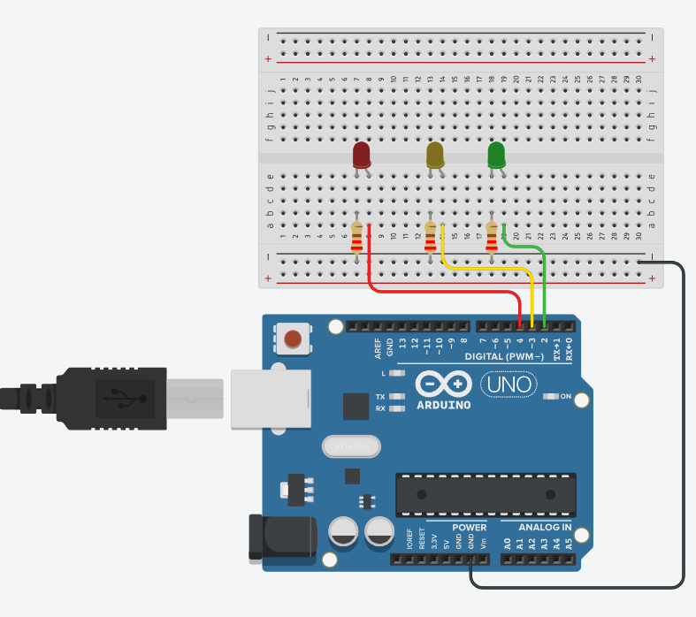
int Green = 2;
int Yellow = 3;
int Red = 4;

void setup()
{
pinMode(Green, OUTPUT);
pinMode(Yellow, OUTPUT);
pinMode(Red, OUTPUT);
}
void loop()
{
digitalWrite(Red, LOW);
delay(1000);
digitalWrite(Green, HIGH);
delay(5000);
digitalWrite(Green, LOW);
delay(1000);
digitalWrite(Yellow, HIGH);
delay(3000);
digitalWrite(Yellow, LOW);
delay(1000);
digitalWrite(Red, HIGH);
delay(6000);
}

